# Shareholder Report: Universal Exports Business Operations – 2022

**Executive Summary:**

This shareholder report is provided to have an understanding of the overall business operation of Universal Exports in 2022.

The major points highlighted are with respect to the following-

1. Income, cost, and profit margins across various periods.
2. Product Diversity Portfolio
3. Sales performance across different countries
4. Sustainability measures in shipment methods
5. **Income, Cost, and Profit Margins:**

In the year 2022, Universal Exports demonstrated strong and consistent financial performance. The company generated total revenue of £963 million, with expenses reaching £529 million. As a result, the organization reported a significant profit of £434 million for the fiscal year. (Fig 1)

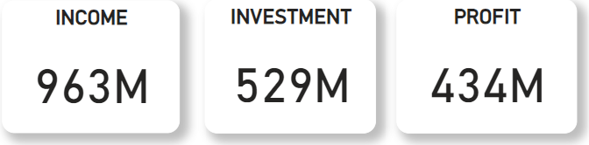

Fig 1

The monthly financial performance showed steady income and investment trends. The average monthly income was approximately £81 million. The only significant changes were in January when there was a drop in the income by £10 million and in June when there was a rise in the income by £5 million. (Fig 2)

The average monthly investment was around £44 million. The only major change in the trend was seen in January when there was a drop in the amount invested by £5 million. (Fig 2)

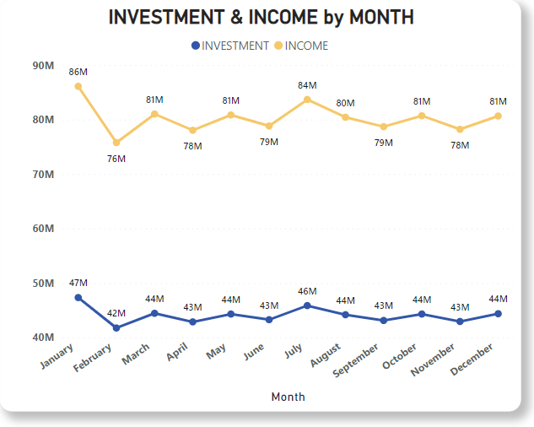

Fig 2

United Exports saw a steady influx of monthly profits at an average of £36 million. The only major change in the trend was seen in January when there was a drop in the profits earned by around £5 million. (Fig 3)

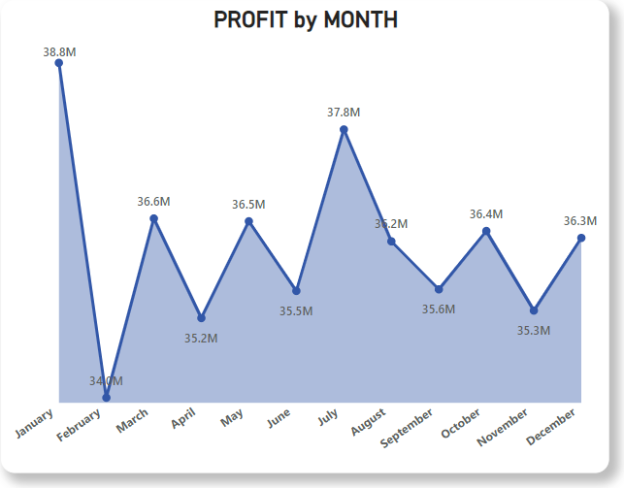

Fig 3

1. **Product Diversity Portfolio:**

United Exports produces and sells 6 different categories of products in total. They are- Hoodies, T-Shirts, Polo Shirts, Jackets, Cardigans and Sweatshirts.

In terms of the number of quantities sold of different product categories, T-Shirts and Hoodies are the most popular, selling close to 15 million each while Cardigans are the least popular, selling around 4.5 million products. (Fig 4)

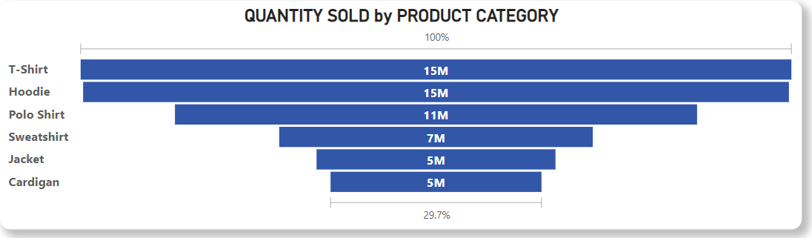

Fig 4

* From Fig 5, it is clearly evident that products of the colors- Blue, White and Grey are the most popular, with around 5.1 million products of each of the above colors being sold.
* It must also be noted that products of the color- Aqua are not a customer favorite as only 1.7 million such products were sold.
* It is to be noted that the least favorite products of colors were those of Beige, Pink and Aqua.

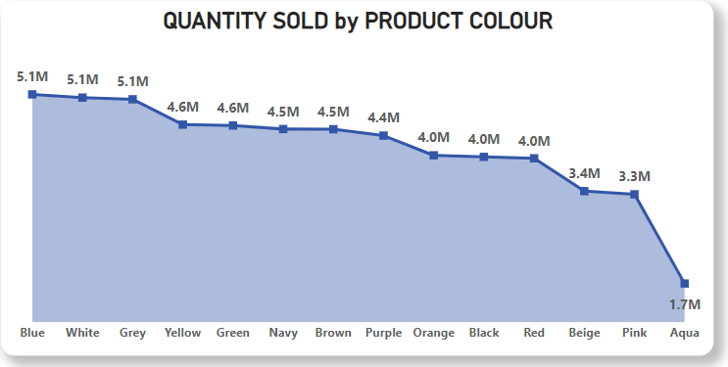

Fig 5

In terms of the profits incurred, Hoodies have generated a staggering profit of £144 million, while Sweatshirts have brought in a meager profit of £20 million. (Fig 6)

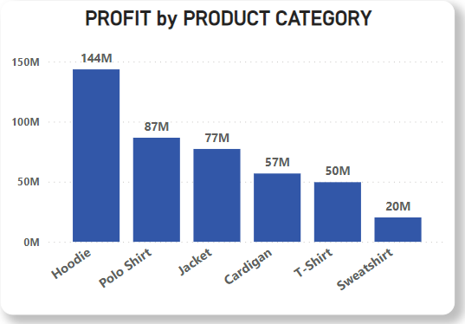

Fig 6

* It must be noted that even though T-shirts and Hoodies are sold the most, Hoodies rake in the most profits, while T-shirts have brought in a much lesser profit of £50 million in comparison.
* Therefore, it would bode well for the future if more quantities of Hoodies are made, preferably of colors- Blue, White or Grey.
* The number of Polo Shirts designed must also be increased as they are the 3rd most popular product category, while also bringing in the 2nd highest profit of £87 million.

1. **Sales Performance across different Countries:**

Universal Exports sells its products all around the world. They serve 22 countries. (Fig 7)

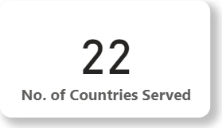

Fig 7

Out of the 22 countries served, it is seen in Fig 8 that the most number of products are being sold in the United Kingdom (11.6 million) as United Exports is based out of Southampton, United Kingdom, followed by France (6.4 million) and Spain (5 million).

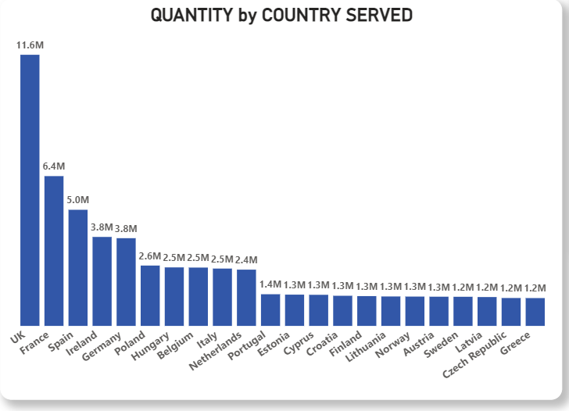

Fig 8

* In terms of the countries that bring United Exports the most revenue, the top 5 countries as seen in Fig 9 are the United Kingdom, France, Spain, Germany and Ireland, which are highlighted by the red circles in Fig 10.

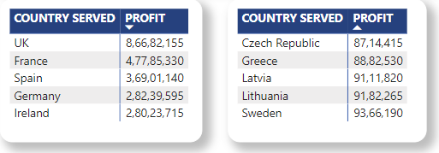

Fig 9

* Since UK, France and Spain are the countries that bring in the most profits and are also the countries where the most quantities are sold, United Exports must continue doing so in the future as well.

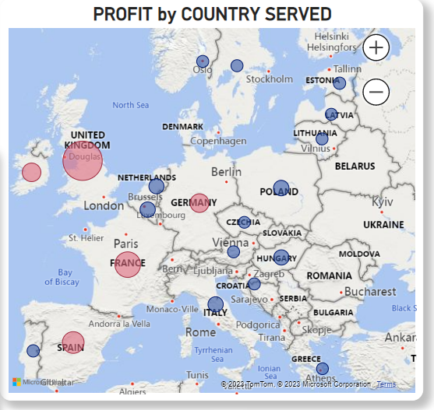

Fig 10

1. **Sustainability measures in shipment methods:**

Due to the sustainable commitment, United Exports had planned on reducing the use of

exclusive air shipment from July 1st onwards. As seen in Fig 11, after selecting the required date range (from July 1st) and the type of shipment required- Air, the total shipments are found to be 4351. (Fig 12)

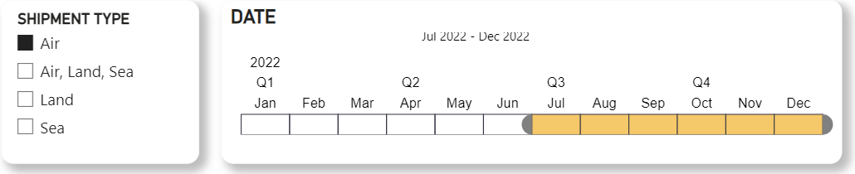

Fig 11

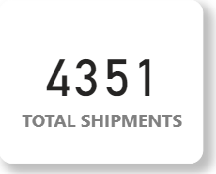

Fig 12

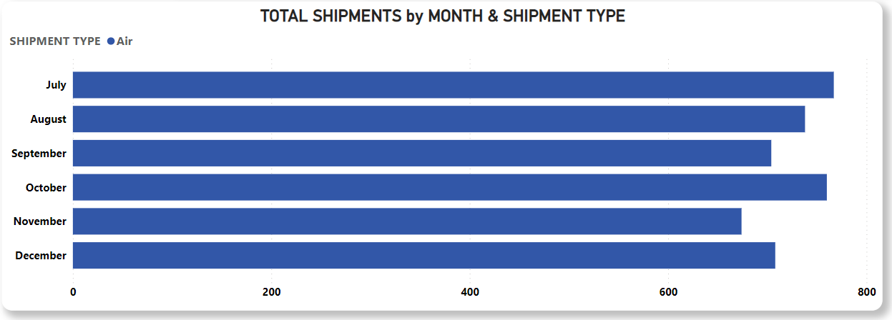

Fig 13

After selecting the required date range (until July 1st) and the type of shipment required- Air (Fig 14), the total shipments are found to be 4344. (Fig 15)

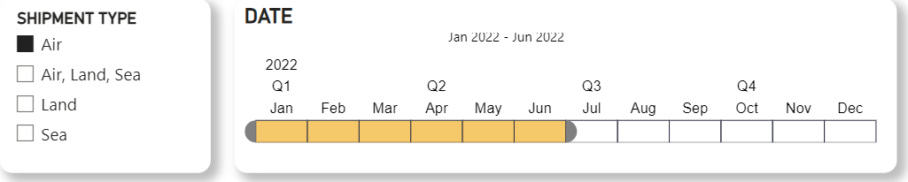

Fig 14

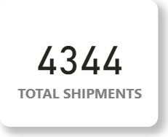

Fig 15

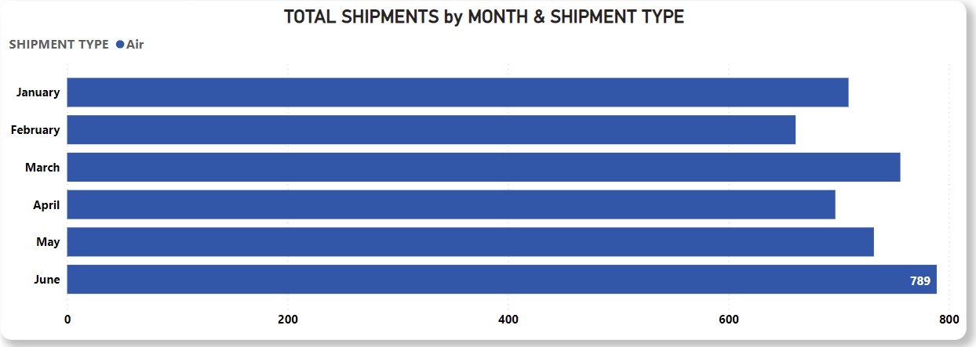

Fig 16

* As seen from the above data, the number of air shipments post-July 1st is 4351, while before July 1st is 4344. This goes on to show that the commitment to sustainability has not been met as the number of exclusive air shipments has marginally increased when the goal was for it to decrease.

**Conclusion:**

* United Exports has performed remarkably well in the year 2022 as seen by the amount of income generated and is well set for the near future as seen by the amount of steady profit being generated every month.
* The best-selling products, product colors and categories have also been identified as well.
* United Export’s largest selling markets have been identified.
* The only area of concern is the company’s failure to achieve its goal of achieving sustainable commitment. Even if this has not affected the revenue in any significant way, catering to this area of concern would bode well for United Export’s brand image and reputation.

# Internal Report: Salespeople Performance - Universal Exports, 2022

**Executive Summary:**

This internal report provides an in-depth review of the performance of salespeople at Universal Exports in 2022.

The key metrics highlighted are -

1. Sales and Revenue Generation

b) Customer Acquisition and Retention

c) Focus on Profitable Products

1. **Sales and Revenue Generation:**

There are 22 salespeople that are employed by United Exports. (Fig 1)

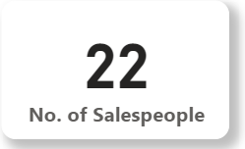

Fig 1

Out of these 22 people, the revenue generated by each of them is illustrated in Fig 2.

* It is seen that Salesperson ID- 22 is the best-performing employee of the year as the person has brought in a staggering income of £125 million.
* Salespeople of IDs- 8, 21, 7, 11, 20 and 12 have performed significantly better than their peers too.

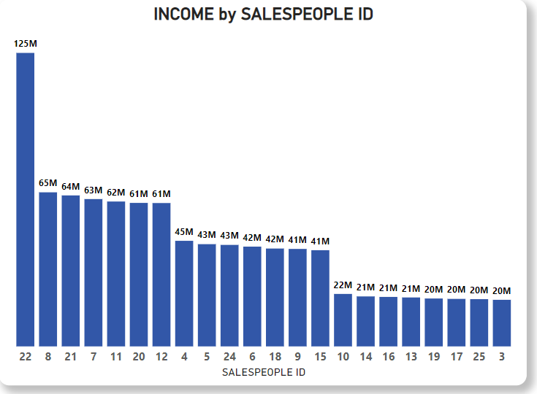

Fig 2

* As seen in Fig 3, Female Salespeople brought in significantly more income of £561.75 million as compared to their male counterparts, who generated £401.19 million income.

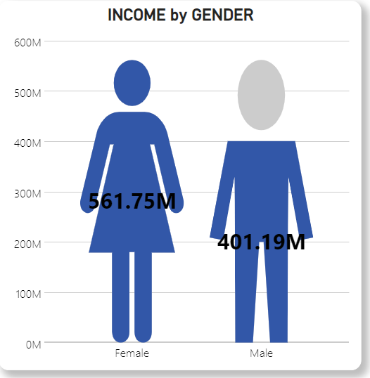

Fig 3

* Female Salespeople also generate more profit £254 million (59% profit percentage) as compared to their male counterparts who generate £181 million profit (41% profit percentage). (Fig 4)

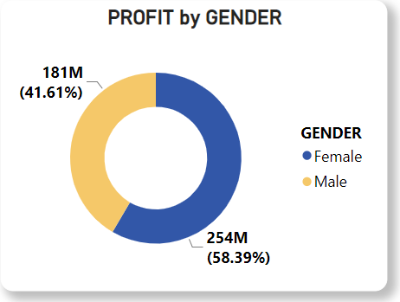

Fig 4

It is also seen that the number of distinct nationalities of the salespeople is 14. (Fig 5)

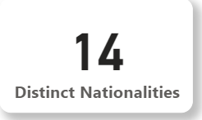

Fig 5

Salespeople of English and Hungarian nationalities generate the most income. i.e. £164 million and £125 million respectively. (Fig 6)

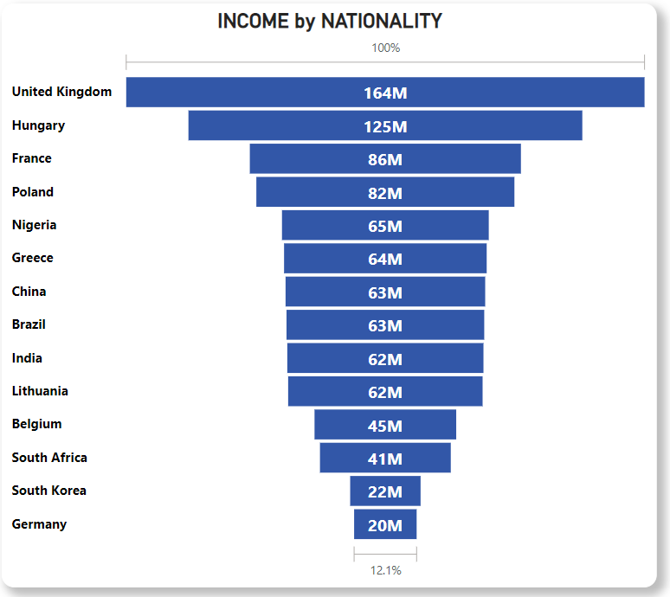

Fig 6

Based on the criteria of the Education level of the Salespeople, it is classified under Undergraduate Degree and Master Degree.

On selection of Master Degree, the following data is seen-



Fig 7

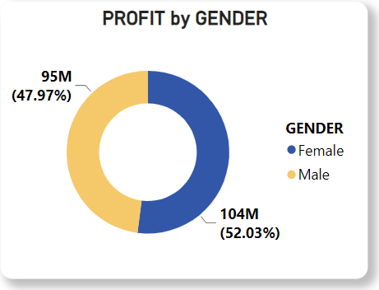

Fig 8

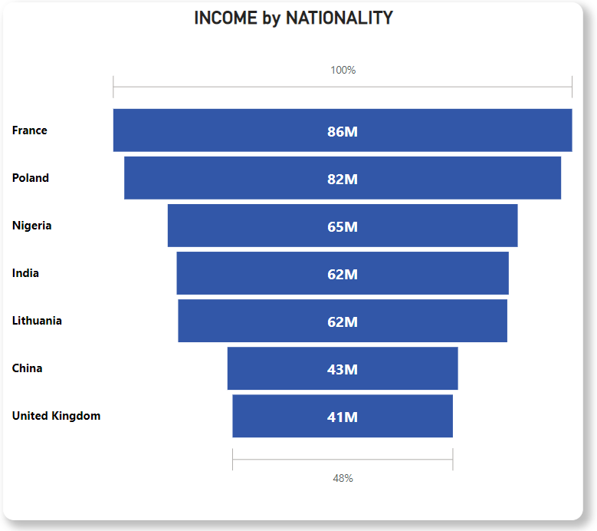

Fig 9

* It is seen that the profit percentage of Female Salespeople has dropped from 59% to 52% and that of Male Salespeople has risen from 41% to 48%. (Fig 8)
* It is also seen that the French and Polish Salespeople who have done a Master Degree generate the most income. (Fig 9)

On selection of Undergraduate Degree, the following data is seen-



Fig 10

* It is seen that the profit percentage of Female Salespeople has risen from 59% to 64% and that of Male Salespeople has dropped from 41% to 36%. (Fig 11)

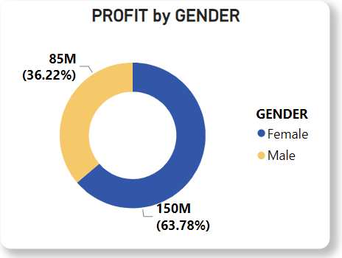

Fig 11

* It is also seen that the Hungarian and English Salespeople who have an Undergraduate Degree generate the most income (Fig 12), which conforms to the general trend as seen in (Fig 6)

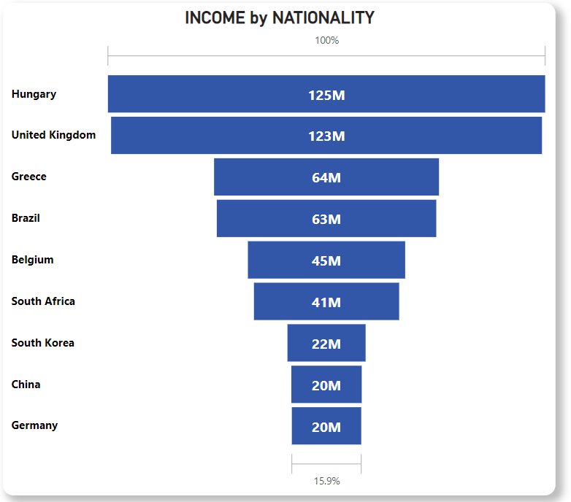

Fig 12

1. **Customer Acquisition and Retention**

Out of the total 48 customers, there were 44 old customers retained and 4 newly acquired customers. (Fig 13) The ‘New Customers’ signifies that these customers had not made any transactions in 2021.

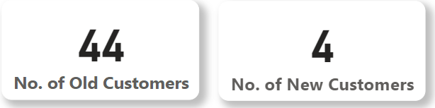

Fig 13

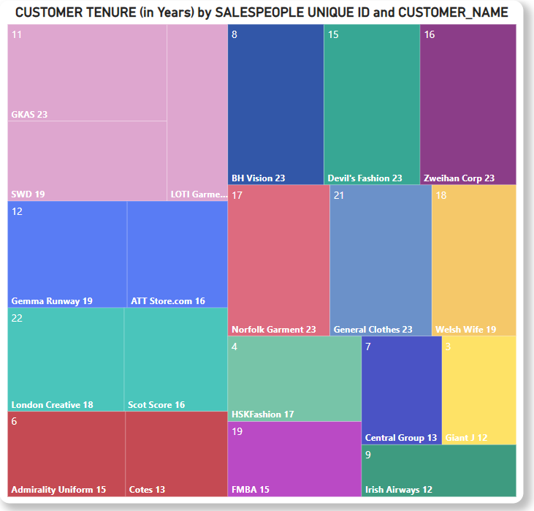

Fig 14

* While looking at Customer Retention, it is worthy of noting that United Export has many long-term customers. Salespeople of IDs -11, 12, 22 and 6 have retained two or more customers for more than a decade. (Fig 14)

Fig 15 illustrates the number of customers each Salespeople ID has retained and how many customers each Salespeople ID has acquired.

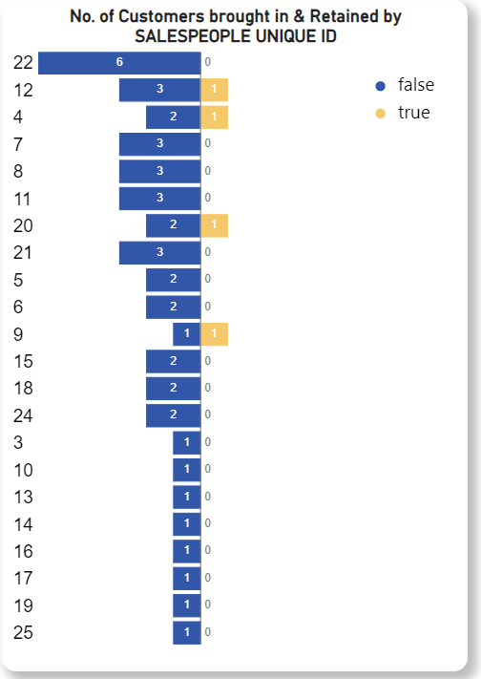

Fig 15

* Salespeople ID- 12, 4, 20 and 9 are the only ones who have acquired new customers.
* Salespeople ID- 22 has exceptional customer retaining ability as 6 existing customers have been retained by this Salesperson.
* Even if the Customer Acquisition strategy might not seem to be working very efficiently, the Customer Retention strategy has been working out exceptionally. This bodes well for United Exports as it illustrates customer loyalty and suggests that the customers are content with United Exports.

Out of the 4 newly acquired customers, only 3 of them have started selling their products. The 3 customers are- Fleur Fashion, Panowikk and EEC Garment. (Fig 16)

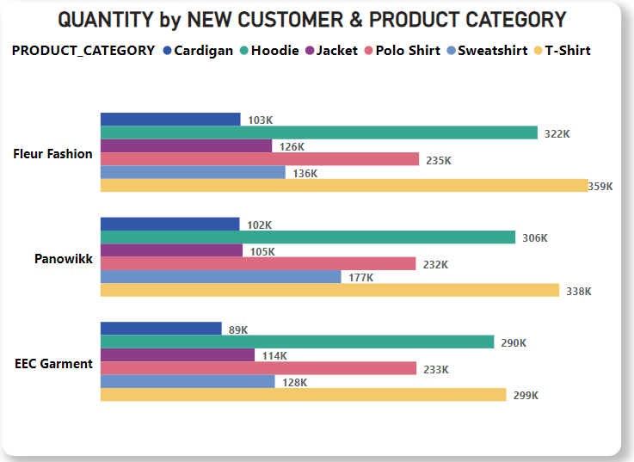

Fig 16

* Of the newly acquired customers, Fleur Fashion sells the most quantities of Cardigans (103K), Hoodies (322K), Jackets (126K), Polo Shirts (235K) and T-Shirts (359K).
* The only product category where Fleur Fashion’s products are not selling the most is that of Sweatshirts.
* Panowikk sells the most quantities of Sweatshirts (177K).

In order to determine whether the acquisition of these customers has been successful or not, the Income generated by the new customers and those by the existing customers was calculated. (Fig 17)

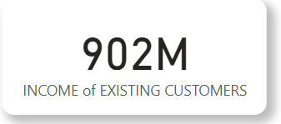 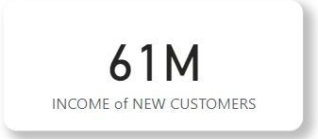

Fig 17

* The newly acquired customers have been a valuable addition since they are already contributing to 6% of the overall profit. (Fig 18)

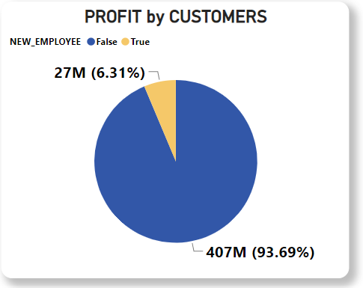

Fig 18

**c) Focus on Profitable Products**

* Fig 19 sheds light on the most profitable products. It is seen that out of the total profit of £434 million, Hoodies contribute the most to the profit with an amount of £143 million, while the second best selling products are the Polo Shirts which generated a profit of £86 million.
* It is seen that when it comes to Hoodies, no color stands apart from the other as Hoodies of every color other than Aqua have all sold well and have generated profits of £10 million each respectively while Aqua-colored Hoodies brought in profits of just £4 million.
* Xtra Sport Hoodie for Athlete in Black was the most profit-generating product of the best-selling Hoodie color category.

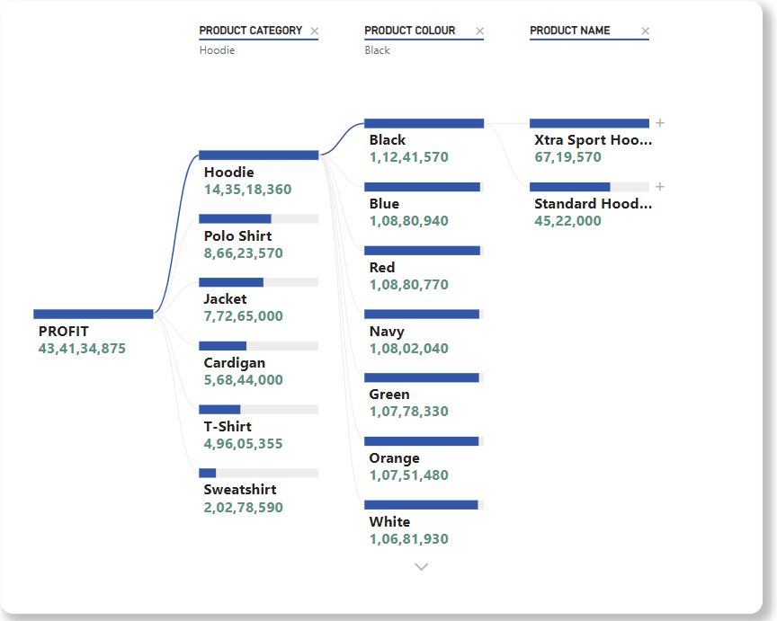

Fig 19